GLAM Meeting
Date: | Monday, 27 March 2017
Time: | 12 noon – 5 pm (arrivals from 11.30am)
Venue: | V&A Blythe House  Archive & Library Study Room and Clothworkers’ Centre  23 Blythe Road, W14 0QX London

11.45-12 | Arrivals
12 – 12.10 | Welcome | David Sutton
12 – 12.30 | Opening session – David Wood OBE “The National Children’s Dramatist”
12.30 – 1 | Seven Stories: working with David Wood and his collection | Sarah Lawrence, (Seven Stories)
1 – 1:45 | Lunch
1:45 – 2.45 | Introduction to V&A Theatre and Performance Collection: A walk and talk through the stores with collection items on display | Ramona Riedzewski (V&A)
2.45 – 3.10 | Literary collections at the Fitzwilliam Museum | Suzanne Reynolds (Fitzwilliam Museum)
3.10 – 3.40 | The Carmen Callil Digital Archive – automated processing and mapping to ISAD(G)  Updates from the Cataloguing working group | Eleanor Dickens (British Library)  Jo Norledge  (British Library)
3.40 – 4.00 | Break
4 – 4.45 | BGM  - Election / confirmation of Officers 2017-2019  - GLAM membership (Secretary)  - Report from Treasurer  - Report from Web Officer  - Chair’s report and review  - Report from the Committee March 2017  - News from members

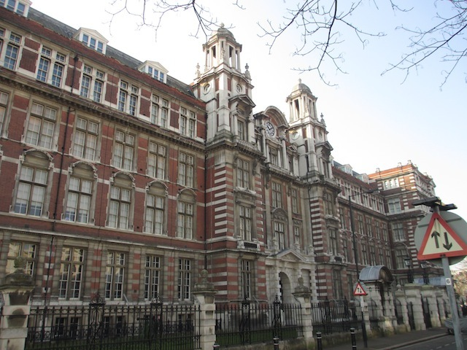 | Directions  to  V&A Blythe House

- All visitors must make their way to Gate B of Blythe House. Please press the bell and our receptionist will let you into the building.
- The nearest station is Kensington Olympia, served by Southern trains, the Overground (good trains to/from Clapham Junction) and the very occasional District Line (although we tend to advise not to rely on the Olympia District Line branch).
- Barons Court tube station – served by Piccadilly Line and District Line – is ca. 10 mins walk away.
- West Kensington tube station – served by District Line – is ca. 10 mins walk away.
- Hammersmith is ca. 15 mins walk way.
- There are a number of busses stopping nearby on Hammersmith Road.
More details on directions may be found towards the bottom of this website:
http://www.vam.ac.uk/content/articles/a/archives/

